JAPAN  
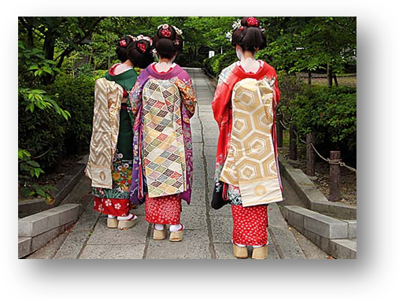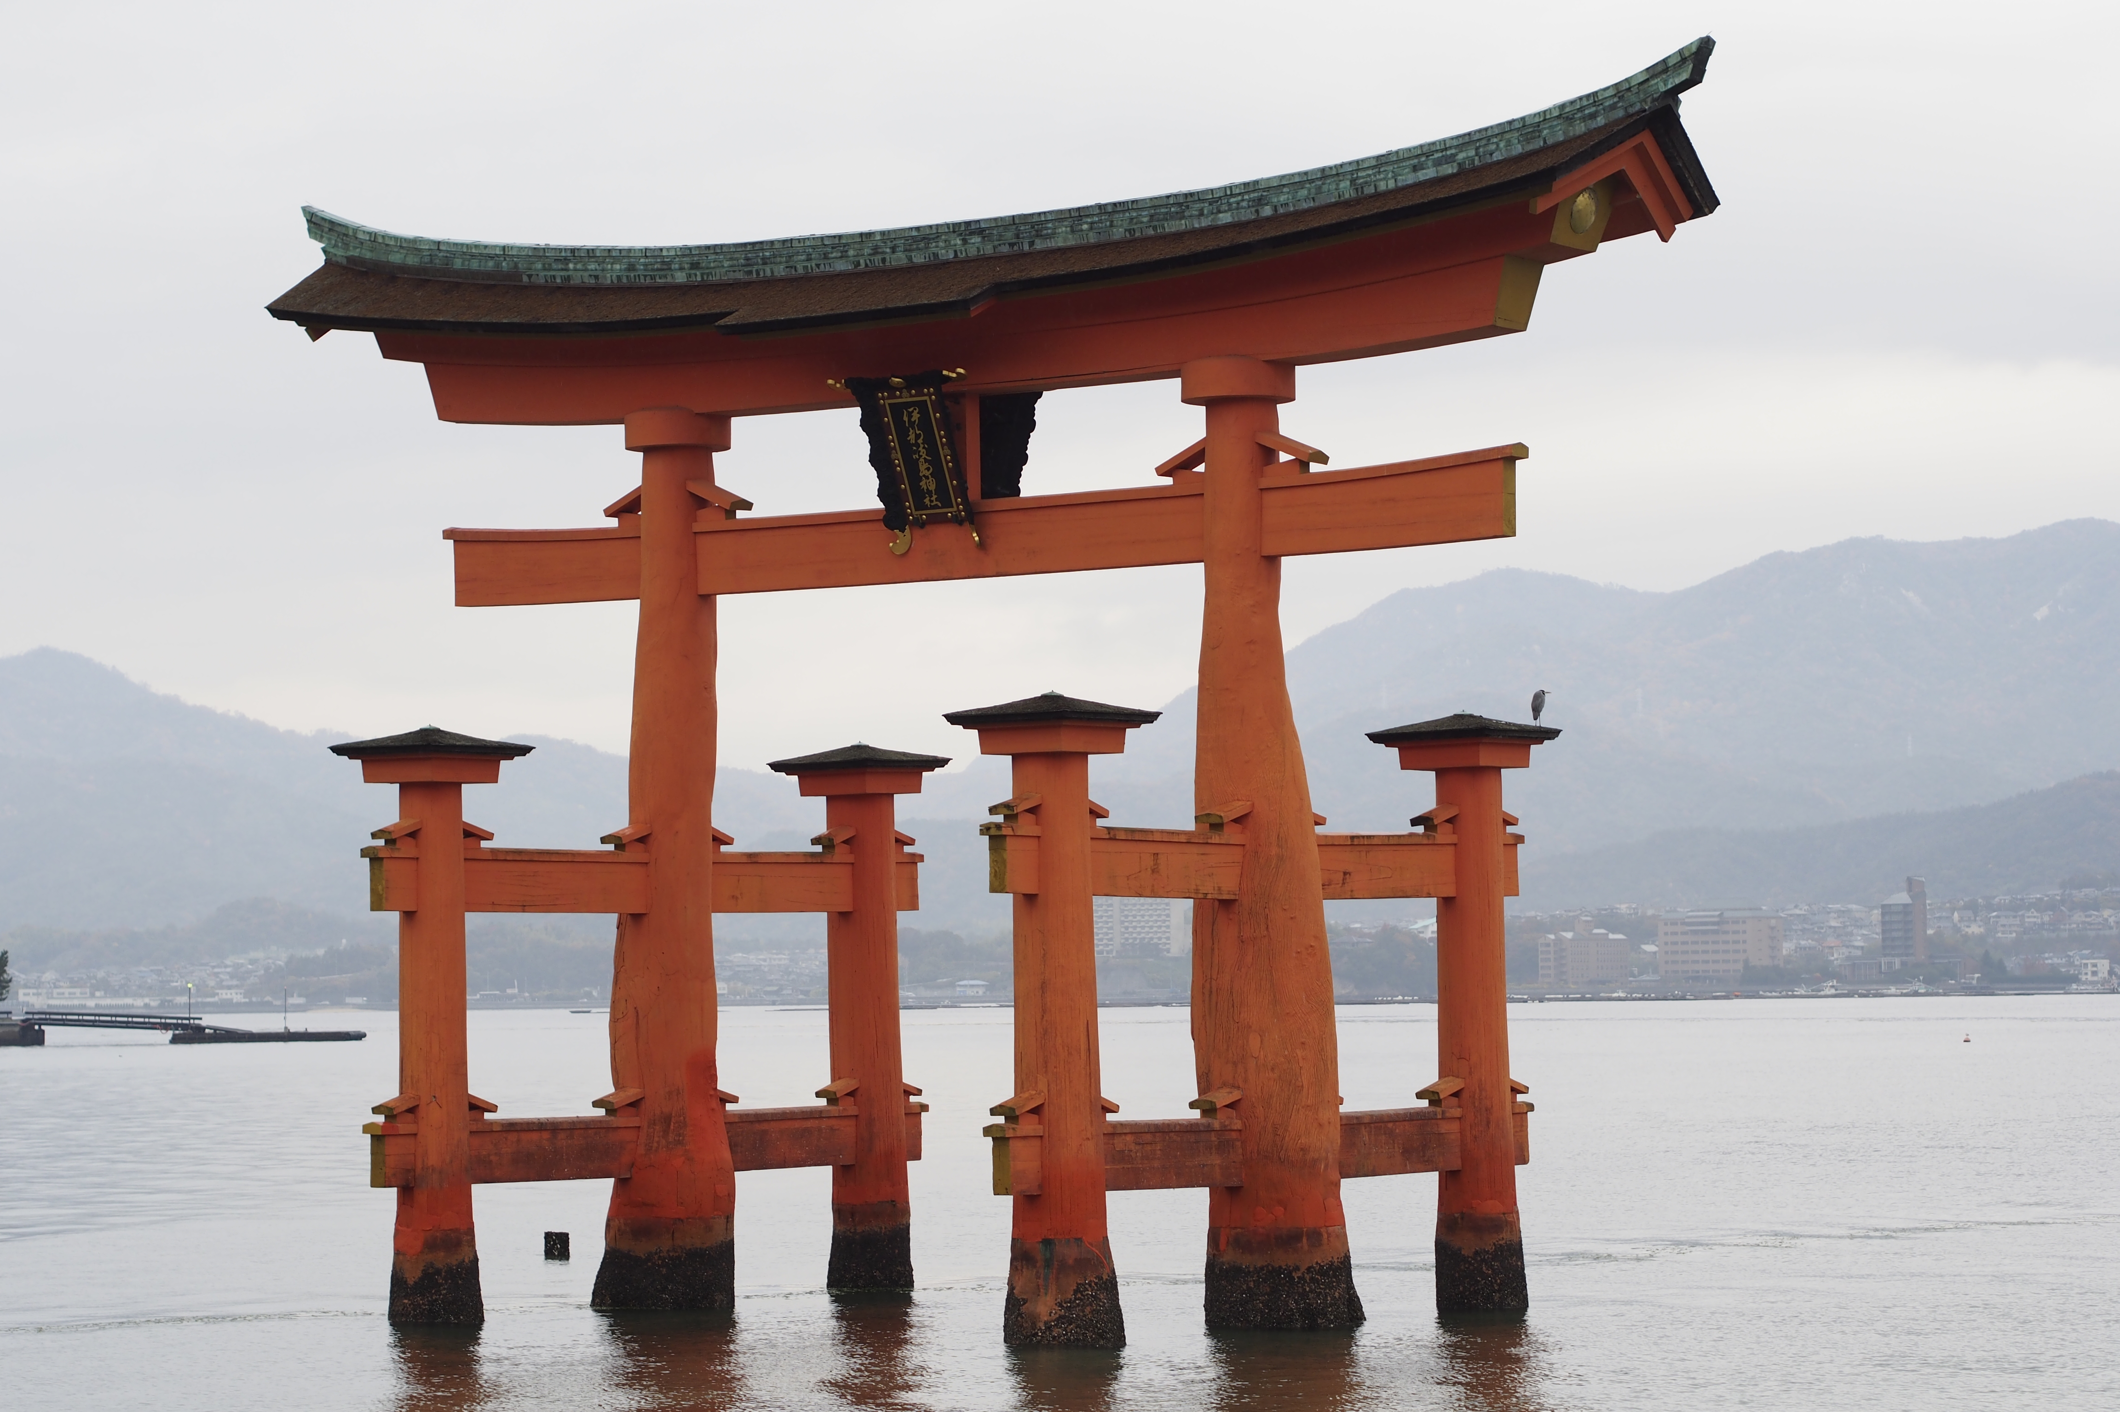[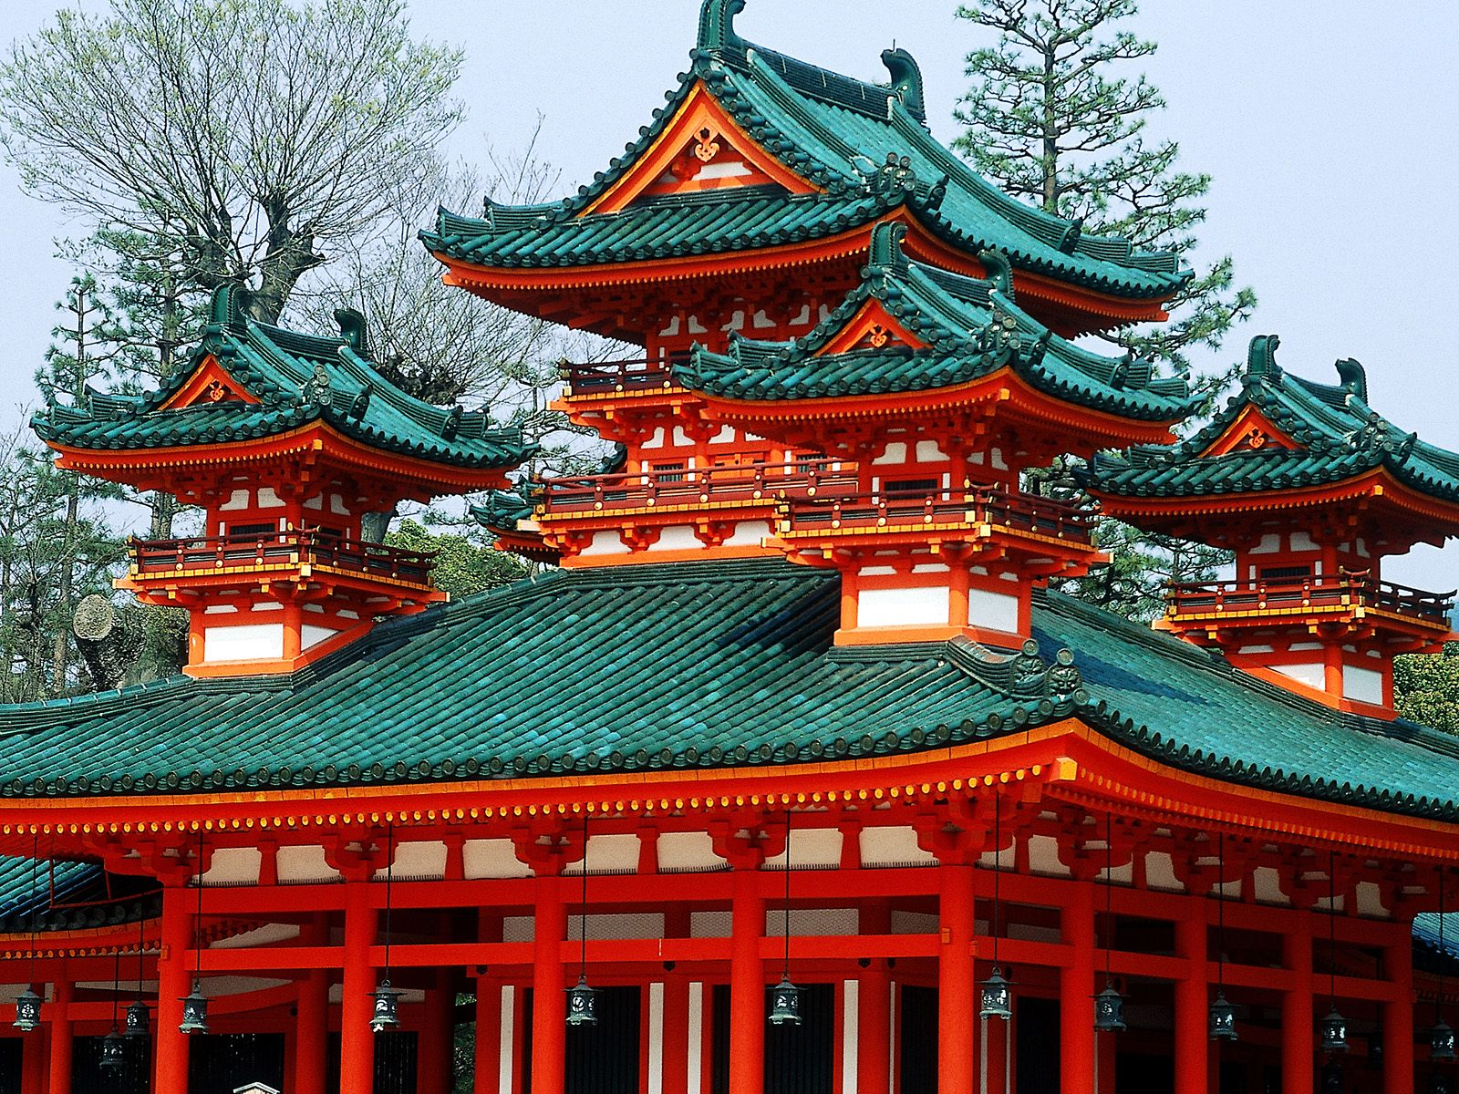](http://www.google.co.nz/url?sa=i&rct=j&q=&esrc=s&frm=1&source=images&cd=&cad=rja&docid=ewA1O5X-0nwIuM&tbnid=j9h5WO2236nFnM:&ved=0CAUQjRw&url=http://bernesga.eis.uva.es/pluswalppaper/&ei=WJKCUvreGMmLkQW0jYGQAQ&bvm=bv.56343320,d.dGI&psig=AFQjCNGk68ZxPJh7iaEolmE_EcnniryfGw&ust=1384375153433966)

**April ‘16**

**Sat 02 ARRIVE TOKYO B**

On arrival into Narita Airport, Tokyo you will be welcomed by your English speaking transportation coordinator and escorted to your car for the transfer to the hotel.

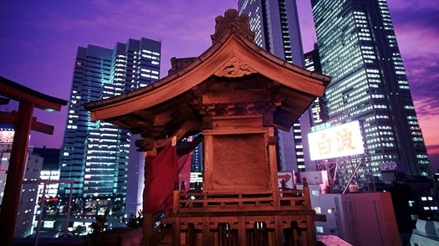

*Tokyo is Japan's capital and the world's most populous metropolis. This bustling city has been described as one of the three "command centres" for the world economy, along with New York City and London. For the visitor, Tokyo offers a seemingly unlimited choice of shopping, entertainment, culture and dining choices. For history buffs, the city's history can be appreciated in districts such as Asakusa where the atmosphere of Tokyo’s past decades still survives, and in the many excellent museums, historic temples and gardens. Contrary to common perception, Tokyo also offers a number of attractive green spaces in the City Centre and environs.*

**Accommodation: The Hotel New Otani (Garden Tower)**

Accommodation In: 02 Apr 15 / Out 06 Apr 15

**Sun 03 TOKYO B**

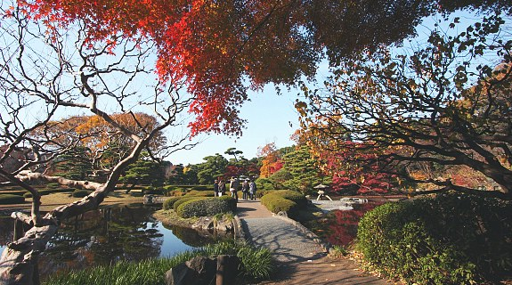

Enjoy a private full day Tour with an English speaking guide.

Highlights include Asakusa Kannon Temple, Nakamise Shopping Street, Sumida River cruise, Hamarikyu Garden & Ginza District

**Mon 04 TOKYO**

Enjoy a private day tour of Tokyo with English speaking guide

Highlights include: the Tsukiji Fish Outer Market, Shibuya, Harajuku, Meiji Shrine & Observatory at the Tokyo Metropolitan Government Office.

**Tue 05 TOKYO B**

Have fantastic full day at leisure to enjoy this wonderful city

**Wed 06 TOKYO – YUDANAKA ONSEN B, D**

Morning transfer to the Train station with an English speaking guide by private bus to catch the bullet train to Nagano (2nd class / with guide). On arrival you will transfer to Yudanaka Onsen where you will enjoy a walking tour of Jigokudani Yaen Koen.

Dinner will be a the Ryokan

**Accommodation: Ryokan Biyuno Yado**

**Thu 07 YUDANAKA ONSEN – NAGANO - MATSUMOTO B**

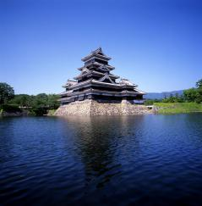

After a full breakfast the will be a morning tour of Nagano that will take in Zonjoji before taking the bullet train (2nd class / with guide) to Matsumoto.

Take a guided walk taking in Nakamachi and Matsumoto Castle

**Accommodation**: Matsumoto Marunouchi

**Fri 08 MATSUMOTO – NAGISO – TSUMAGO B, D**

Morning bullet train (2nd class / with guide) to Nagiso for a half day tour by local bus

Highlights: Tsumago Village

**Accommodation: Hotel Kisoji**

**Sat 09 NAGISO – HIROSHIMA B**

Take the bullet train from Nagiso to Hiroshima (with a change at Nagoya). There will be no guide on the train

**Accommodation: ANA Crowne Plaza, Hiroshima**

**Sun 10 HIROSHIMA - MIYAJIMA B**

Today you will explore World Heritage sites in Hiroshima and Miyajima.

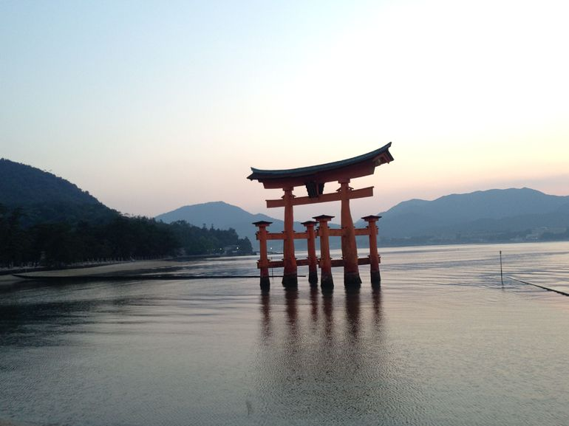

Hiroshima visit the Peace Memorial Museum, Peace Memorial Park, A – bomb Dome and Miyajima is famous for its Itsukushima Jinja Shrine. Its red torii gate appears to be standing in the sea during high tide. Walk through the Hiroshima Peace Memorial Park, dedicated to promoting peace around the world.

Return to Hiroshima for the night

**Accommodation: ANA Crowne Plaza, Hiroshima**

**Mon 11 HIROSHIMA – OSAKA – KOYASAN B, D**

Separate Luggage Transfer from Hiroshima to Kyoto / 1 bag per passenger / overnight transfer. Bullet train form Hiroshima to Shin-Osaka and then local train from Namba to Gokurakubashi where you will take a cable car ride from Gokurakubashi to Koyasan before enjoying a local bus sightseeing.

Highlights Okunoin cemetery and Kongobuji Temple

**Accommodation: Shukubo Rengejoin**

**Tue 12 KYOTO**

After breakfast take a local bus to Koyasan station (non-reserved seat) where again you will need to take the cable car to Gokurakubashi and then the Nankai Express train to Namba and then Kyoto. Today you will experience a half day tour of Kyoto, the former imperial capital. Kyoto is the Centre of artistic and cultural history with its temples, gardens and traditional courtyards. Visit Niji Castle, Kinkakuji Temple, Ryoanji Temple and Kiuyomizu Temple – a UNESCO World Heritage site and considered Japan’s most-loved temple.

Our first visit for the day will be to Niji Castle, built by the founder of the Edo Shogunate as his Kyoto residence. The main building, completed in 1603, is famous for its Momoyama architecture, decorated sliding doors and ‘chirping’ nightingale floors. The castle is surrounded by stunning gardens.

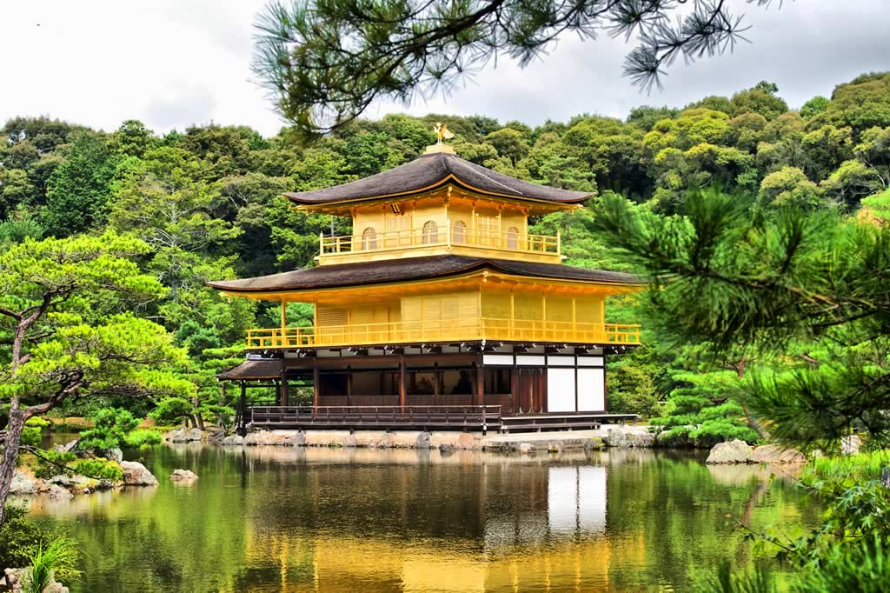Ryoan-ji Temple is famous for its mysterious rock garden, the most celebrated in Japan, which defies attempts at explanation.

The expression "to jump off the stage at Kiyomizu" is the Japanese equivalent of the English expression "to take the plunge". Kiyomizu-dera Temple is perhaps the most beloved of Kyoto's temples and is a fixture in the minds of the Japanese people.

**Accommodation: ANA Crown Plaza Hotel, Kyoto**

**Wed 13 KYOTO B**

A full day private tour of Kyoto with an English speaking guide

Highlights Ginkakuji Temple, Philosopher’s Walk, Nanzenji Temple, Sanjusangendo Hall, Kiyomizu Temple and Gion Walking

**Accommodation: ANA Crowne Plaza Hotel, Kyoto**

**Thu 14 KYOTO – OSAKA B**

Enjoy a free morning in Kyoto and an afternoon tour of Osaka with an English speaking guide

Highlights include Osaka Castle and Dotonbori shopping street

**Accommodation: Hotel Granvia, Osaka**

**Fri 15 OSAKA – KANSAI AIRPORT – DEPART B**

Today will be your last day and after breakfast you will have a transfer to the airport for your flight home

**~ Your Japanese Journey Concludes ~**